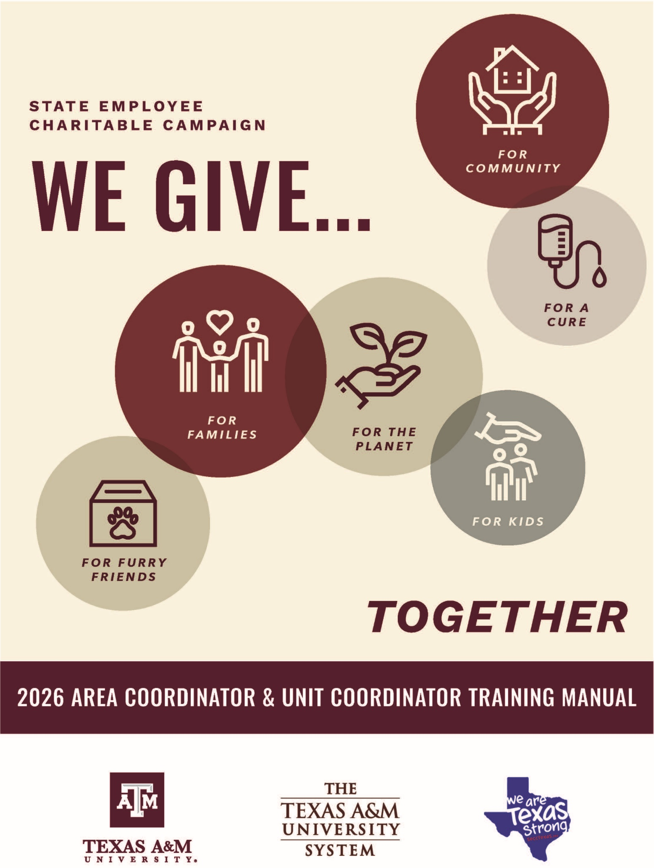

TABLE OF CONTENTS

2026 SECC CONTACT INFORMATION 2
Website information
Campaign Timeline
Campaign Theme and Slogan
WHAT IS THE SECC? 4
History & The SECC Advantage
HOW IS THE SECC MANAGED? 5
United Way of the Brazos Valley
University & System Campaign Chairs and Managers
Area Coordinators
Unit Coordinators
Financial Management Operations
HOW DO EMPLOYEES PARTICIPATE? 6
Payroll Deductions through SSO
Automated Authorization Form
Credit Card Gifts
Square Processing
Fundraising Efforts
Designating a Gift
Leadership Givers
WHAT IS AN AREA COORDINATOR? 12
Administrative Responsibilities
Financial Responsibilities
Area Coordinator Thursday To Do List & Helpful Resources
WHAT IS A UNIT COORDINATOR? 16
Administrative Responsibilities
One-Time Gift (Cash/Checks)
Fundraisers
Unit Coordinator Wednesday Morning To Do List
SUMMARY OF FORMS 19
Fundraiser Participation Form
Automated Higher-Education Authorization Form- Fundraising & Individual (Employees/Area & Unit Coordinators)
FORM 2 & 4 (Area & Unit Coordinators)
Pledge Report Envelope (Area Coordinators)
Deposit Bag (Area Coordinators)
SECC CALENDAR 26

2026 SECC CONTACT INFORMATION
TAMU Campus Campaign
peter lange monica martinez
A&M Campus Campaign Chair A&M Campus Campaign Manager
Operations Operations
400 Bizzell, 2302 TAMU 400 Bizzell, 2302 TAMU
College Station, TX 77843 College Station, TX 77843
979-458-0287 | plange@tamu.edu 979-845-4680 | mmartinez@tamu.edu

System Offices Campaign
Mandy starK
A&M System Offices Staff Council
A&M System Campaign Chair/Manager
301 Tarrow St College Station TX 77840
staffcouncil@tamus.edu mstark@tamus.edu
979-458-7120

UNITED WAY TAMU Campus
OF TEXAS Liasion
Greg Bennett Kim fox
State Campaign Manager Manager,
106 E 6th St Ste 900-116 Division of Community Engagement
Austin, TX 78701 Administration Bldg., Rm 318G
1245 TAMU
512-694-2872 | greg.bennett@uwtexas.org College Station TX 77843
979-845-8008 | kfox@tamu.edu

2026 SECC WEBSITES
STATE OF TEXAS SECC WEBSITE
secctexas.org
Visit this website for information, forms, list of approved charities and the SECC logo.

THE A&M SYSTEM SECC WEBSITE
tamus.edu/secc OR TX.Ag/SECC
Visit this website for campaign information, forms, updates and guidance.

FACEBOOK PAGE
facebook.com/TAMUSECC
Visit the Facebook page to see what’s happening around College Station during this year’s campaign.

SECC Campaign Timeline

The annual campaign will run from September 1 through October 31 of each year with an additional few weeks into November for final deposit processing.

2026 SECC Campaign theme & Slogan

We Give….

Whether it's to support kids and families, the planet we call home, finding a cure for a disease, or for general community support, we all have our own reason to give. While the 'WHY' behind our giving may be different, the outcome is what really matters.

The State Employee Charitable Campaign is the opportunity for each employee to transform their 'why' into meaningful change. So WHY DO YOU GIVE? #WeGive #WhatsYourWhy

What is the State
Employee Charitable Campaign (SECC)?
HISTORY
The SECC was created by legislation in 1993. The first campaign was conducted in 1994 and offered Texas state employees greater giving options with hundreds of charitable organizations in which to designate gifts.
The SECC is a great opportunity for state employees to contribute toward helping improve the quality of life for tens of thousands of individuals who need our support.
The campaign provides state employees with a convenient and efficient way to make voluntary, tax-deductible contributions to the charities of their choosing through payroll deductions or one-time payments by cash or check.
In our diverse society, with needs changing rapidly, the SECC is an opportunity for state employees to make a difference in the lives of others. Together we can make a difference in the lives of our families, friends and neighbors across the great state of Texas and across the country.

The SECC Advantage
There is no easier way for state employees to give. Here’s why the SECC is the smart way to give:

Choice!
No other charitable campaign offers so many choices. There are over 1,000 charitable organizations across the state to choose from. This allows employees to decide which organizations best address your concerns, passions, and interests.

Confidence!
All agencies participating in the SECC meet strict eligibility standards established by state law and are screened by the SECC State Policy Committee. Therefore, you can feel confident your gift is being used efficiently and effectively by your designated charities.

Convenience!
For employees of The Texas A&M University System, the SECC provides a convenient way to donate in a method that works best for you. Giving options include:
- Recurring online payroll deduction
- One-time payroll deduction, deducted the first payroll of the new calendar year
- Credit card donation, frequency selected by you
- Gifts through cash and check, during September and October

We encourage employees to take advantage of the giving method that works best for them!

How is the SECC managed?
United Ways of Texas
United Ways of Texas oversees the campaign at the local level for several counties in the Brazos Valley area. As the Local Campaign Manager (LCM), they ensure the campaign is conducted fairly and equitably under a strict set of guidelines. The State Campaign Manager is responsible for the financial and operational management.
University and A&M System CAMPAIGN Chairs AND Managers
All agencies and institutions in the A&M System participate in the SECC. Due to the size of the A&M System workforce in the College Station area, two separate campaigns are conducted. One campaign includes Texas A&M University employees and is chaired by a university employee. The other campaign includes employees of the System Offices and A&M System agencies headquartered in the College Station area. This campaign is chaired by an employee on the System Offices Staff Council. Each campaign has one or more campaign managers to help with the administration of the respective campaign.
The campaign chairs and campaign managers coordinate activities and provide training and materials to the designated area and unit coordinators. The campaign managers also maintain a close relationship with the area coordinators throughout the campaign to answer questions which may arise.
Area Coordinators
University department heads and agency chief executive officers appoint area coordinators to conduct the campaign for each division, department, agency or other group area. The area coordinator:
- Works closely with the university or system campaign managers to ensure the success of the campaign
- Serves as a trainer, motivator, facilitator, and resource for the unit coordinators
- Distributes materials to their area employees
- Collects weekly report forms
- Serves as a line of communication between employees and campaign leadership.
Unit Coordinators
Unit coordinators are appointed by each area coordinator to further assist with department level campaigns. The unit coordinators are responsible for:
- Educating and energizing individual employees about the SECC
- Providing the materials necessary for participation in the campaign
- Collecting the necessary paperwork each week and processing it in accordance with established guidelines.
Financial Management Operations
Texas A&M University Financial Management Operations (FMO) has developed guidelines for collecting and depositing donations to ensure proper controls over employee paper and electronic donations. Representatives are available to answer questions as necessary. All cash and check donations made during the campaign must be processed in accordance with these established procedures.
How Do employees Participate?

payroll deductions through sso

Employees are strongly encouraged to participate in the SECC through the A&M System Single Sign-On portal sso.tamus.edu. Through this process, employees can submit the authorization for monthly payroll deductions or for an immediate, one-time donation.

The “total monthly gift” represents the total monthly deduction.

Employees select 9 or 12 pay periods for the payroll deduction based on their number of pay periods. The “total annual gift” is calculated by adding the total monthly gift for each designated charity and multiplying this total by 9 or 12.

PLEASE NOTE:
- The minimum monthly donation is $2 per charity.
- Deductions for employees paid monthly will begin in December and will be reflected on the January payroll of the new calendar year.
- Deductions for employees paid bi-weekly will begin in January and will be reflected in the second payroll of each month.
- Payroll deductions can be stopped at any time by contacting the payroll office.
- Deductions are made after taxes are withheld. Employees should retain a copy of their online designation for their tax records.

Higher-Education Automated Authorization Form

Employees who do not wish to use the payroll deduction option should complete a Higher-Education automated Authorization Form for one-time cash or check donations ONLY. Checks should be made payable to SECC.

https://it-lf-ecmf.tamu.edu/Forms/SECC-HigherEducationAuthorizationForm

Employees complete the form with the following information:
- Select Individual
- Select your Campaign and Campaign Area from the drop-down menus, name, email, UIN, address and phone should prepopulate.
- All fields are required.
- Employee will designate the chair preferred charity. Up to 6 charities can be selected. If more than one charity is selected, breakdown how much each will receive. Make sure the total is equal to the check/cash.
- Employee will receive a confirmation email. Deliver cash/check to employee’s Area or Unit Coordinator for their processing. Area Coordinators will receive a copy of the email confirmation of the donation as well.

** This form is also used by Unit and Area Coordinators for FUNDRAISERS.**

Coordinators complete the form for Fundraisers:
- Select Fundraiser
- Select your Campaign, Campaign Area and department from the drop-down menus
- For “Name”, list unit and fundraiser title. Email, UIN, address and phone should prepopulate.
- All fields are required.
- Submitter will designate individual charities. Up to 6 charities can be selected. If more than one charity is selected, breakdown how much each will receive. Make sure the total is equal to the check/cash.
- If fundraisers include individual contributions of $24 or more, you must also complete the Fundraiser Participation Spreadsheet attached to the form.
- Submitter will receive a confirmation email. Follow normal weekly deposit procedures by delivering cash/check to Area Coordinator for weekly deposit.

ACKNOWLEDGEMENT SECTION
The employee’s gift remains anonymous unless they complete this section. A home mailing address is required for their gift to be acknowledged. Donors are not guaranteed to be acknowledged, based on the charity’s practices.

10% goes to all state and local campaign partners to support the administrative expenses of the SECC. 90% of donations go directly to the charities selected.
CREDIT CARD GIFTS

FOR EMPLOYEES: Employees wishing to make a gift via credit card will visit https://www.secctexasgiving.org/_brazosvalley/. Employees will need to click "New Donors Register Here" to initiate their gift if they have not given through credit card previously.

FOR COORDINATORS:
Square Processing
Coordinators have the opportunity to make use of a square for credit card processing for fundraisers. You can collect payments using physical Square card readers or by enabling Tap to Pay to turn standard smartphones into standalone terminal devices. You can also create QR codes and payment links.

Intake Process: Before setting up any account, event coordinators must submit an internal request form specifying the event date and their specific hardware/account requirements. Fill out the form below:
https://www.secctexas.org/form/square-card-reader-request-form
An invitation to set up your Square account will be sent within 2 business days of the submitted form.

Setting Up "Tap to Pay" for Mobile Devices
Tap to Pay allows coordinators to accept contactless cards, Apple Pay, and Google Pay directly on an iPhone without needing external reader hardware.

Device Checklist & Limitations
- Supported Devices: Must be an iPhone XS or newer. Tap to Pay is not available on iPads.
  - Note: Some Android phone models may be compatible with Tap to Pay. Follow the steps to check that the Tap to Pay option is available. If it is, your device is compatible.
- Credentials: If you log into the app using a temporary "device code," Tap to Pay will be disabled. A staff member must log into the Square POS app using the primary organization owner account credentials to authorize this feature.
- System Settings: The device's Date & Time must be set to "Automatic," an active device passcode must be configured, and it must have a stable internet connection (offline mode is not supported).

Apple Activation Steps
- Open the Square POS app on the compatible device.
- Tap ≡ More > Settings > Account.
- Select Tap to Pay on iPhone and toggle the switch to ON.
- Verify the listed Apple ID, then tap Agree & Continue.

Android Activation Steps
You can enable Tap to Pay on Android at any time through your point of sale app.
- Sign in to your point of sale app and tap ≡ More > Settings > Hardware.
- Select Tap to Pay and toggle on Tap to Pay.

Step-by-step process for Coordinators and SECC volunteers to use Square:

  - Decide how many Square users are needed for fundraising event(s);

  - Get permission – Run event plans and use of Square by your supervisor; Note: Your supervisor will receive an email once you complete the Square Card Reader Access Request form. No other action is required.

  - After receiving leadership approval, sign-up for access to Square: https://www.secctexas.org/form/square-card-reader-request-form , ensuring to carefully ready Square policy and process overview.

  - Send a signed Square Usage Police agreement to your SECC Local Campaign Manager via email (United Ways of Texas if you are in the Brazos Valley);

  - Download Square app on phone(s) to be used at event(s);

  - Once you receive a Square user profile from their SECC Local Campaign Manager, check access and make a test $1 donation;

  - Check Wi-Fi availability at event(s) location(s);

  - Have a back-up plan in case of any technology problems the day of the fundraiser (have back-up Square QR code and consider using personal WiFi hotspots);

  - After event, fill out the Higher Education Automated Authorization Form and the SECC pledge forms as outlined in the deposit instructions under “Area Coordinator Thursday Deposits” section in this manual. Transaction reporting is available to users through the Square app.

  - Be sure and plan to thank volunteers who helped manage fundraising event and employee participants;

  - Keep notes of what worked and what did not and share this information with SECC leaders.

- Donation QR Codes/Payment Links
  - SECC Local Campaign Managers can assist Square users in setting up QR codes and payment links as optional ways to receive payments, if needed as a back-up or alternate to in-person tap to pay/swipe features.

Creating Donation QR Codes & Payment Links
For digital campaigns, online outreach, or printed flyer marketing, administrators can generate direct web checkout links tailored for donations.

Employees must request access to use the Square software to use the QR Codes and payment links. Follow steps above or contact the United Ways of Texas for assistance.

Link Creation Steps
- From the credit card Dashboard, navigate to Payments & invoices > Payment links.
- Click Create Link in the top-right corner.
- From the list of purposes, click Accept a donation.
- Configure Details: Enter a clear Title (e.g., "Annual Gala Fundraiser"). Consult your event coordinator to add a tailored description or upload a custom campaign image.
- (Optional) Toggle on Set donation goal to display a live progress bar to prospective donors.
- Click Save in the top right corner.

Distribution & Sharing
Once saved, the campaign appears in your active library. Clicking on the campaign row opens the distribution panel, giving you three main ways to share it:
- Direct Link: Copy the raw URL for text messages, email newsletters, or social media posts.
- QR Code: Download a high-resolution QR code image to place on printed event posters, flyers, or banners.
- Buy Button: Generate an HTML embed snippet to place a clean "Donate" button on your existing nonprofit website.

Fundraising Efforts
Fundraisers can be fun and are a great way to increase donations and engagement in the campaign. We encourage each area and unit coordinators plan at least two fundraisers over the course of the campaign.

For each fundraiser, a higher-education automated authorization form needs to be completed and charity(ies) selected for designation. Ensure FUNDRAISER is selected at the top of the screen.

We ask coordinators to identify donors who contributed over $24 on a separate attached fundraising participants spreadsheet so we can include this information in overall participation rates in the campaign. Email the fundraiser participant spreadsheet for each fundraising activity to kfox@tamu.edu for documentation of our participation percentage.

designating A Gift
Employees select the charities they wish to support from the SECC brochure or from the SECC directory online (https://www.secctexas.org/search-charities). They may designate up to six different organizations from any three charitable groups (local, national, international).

leadership givers
Leadership giving is optional for donors of $1,000 or more. If a donor donates $1,000 or more and chooses to be acknowledged, the donor’s name will be put in an area wide thank you advertisement and listed in the Campaign Directory for the following year.
If both spouses are employees and would like to make separate donations, the donations can be combined to meet the Leadership Giving threshold of $1,000 or more. This must be coordinated with both employees’ unit coordinators. The unit coordinators should notate in their weekly deposit this joint Leadership giving for either SSO or automated form. Their giving must be turned in during the same week, allowing the United Way to combine the donations.
Leadership giving levels include:
- Yellow Rose: $1,000 - $2,499
- Bluebonnet: $2,500 - $4,999
- Alamo: $5,000 - $9,999
- Lonestar: $10,000
What is an Area Coordinator?
Area coordinators provide the link between the campaign chairs and managers and the unit coordinators. Area coordinators manage activities within their respective area for the university and A&M System campaigns (College/School/Division/Agency).
Administrative Responsibilities
- Serve as a member of the SECC leadership team.
- Provide leadership, oversight and direction for the campaign in your Division/College.
- Review the composition of your area and ensure all employees are assigned to a unit. Appoint unit coordinators for each department to ensure all employees in your area are given the opportunity to participate.
- Establish a campaign fundraising goal for your area and participate in establishing campaign goals with your unit coordinators.
- Represent your area at the SECC kick-off events, training workshops and various meetings.
- Plan and implement training sessions for your unit coordinators as necessary.
- Serve as a motivator, facilitator and resource for your unit coordinators.
- Share information and motivation on a weekly basis with unit coordinators.
- Compile list of contributors for special recognition.

Each week, Area Coordinators will receive the following reports on the activity of the campaign. This information can be shared across their units (verify personal UIN and donation amounts are removed).
  - Special reports can be created on an as needed basis.
  - Weekly Reports:
    - SECC Names List by Area
    - SECC Summary by Area and Date
    - SECC Summary by Area, Type, and Date
    - SECC Employee Participation
    - SECC Credit Card Donation Report
    - NEW – notification emails of Higher-Education Automated Authorization Form Processing

Area Coordinator financial Responsibilities
NO later than Wednesday mornings, collect monies and pledge forms from your unit coordinators and compile the information.

One-time Gifts (Cash/Checks, automated form)
- You will receive a confirmation email when a higher-education automated Authorization Form has been processed. If needed, follow up with Unit Coordinator to ensure cash/check is received to be handled with the upcoming deposit.
- Balance the cash and checks from all units using FORM 2 & 4 (the Cash/Check Total Sheet). Make a copy.
- Fill out the deposit slip.
- Stamp the back of each checks or write “For Deposit Only.”
- Fill out the Pledge Report Form Envelope and make a copy of the deposit slips.
- Place a copy of the deposit slip, the printed confirmation of higher-education automated authorization form, and FORM 2 & 4 in the Pledge Report Form Envelope.
- ONLY put checks and/or cash and the original deposit slip in the plastic bank deposit bag and seal it. Write “SECC Deposit” on the bag. Tear off filled out tab and keep with your records. All of these will then be delivered to Financial Management Operations (FMO), formerly DAS.
- Cash over $100 should not be held overnight. Put the cash in a locked safe until the Thursday deposit or make an early deposit to FMS on the 3rd floor of the GSC suite 3401 by following the normal deposit guidelines. DO NOT place in the lockbox by the 3rd floor restrooms.

Fundraisers (Cash/Checks)
- Balance the cash and checks from all units using FORM 2 & 4, the Cash/Check Total Sheet, and make a copy.
- Fill out a deposit slip.
- Stamp the back of the checks or write “For Deposit Only.”
- Fill out the Pledge Report Form and make a copy of the deposit slips.
- The Pledge Report Form, the deposit slip, the printed confirmation of higher-education automated authorization form and FORM 2 & 4 go to FMS.
  - Note: The higher-education automated authorization forms and deposit slips should balance with the total on the Pledge Report Form.
- ONLY put the checks and/or cash and the deposit slip in the plastic bank deposit bag and seal it.

Fundraisers (Tap to Pay/Square)
- Create a separate higher-education automated authorization form just for CREDIT CARD transactions. *This means you may have 2 forms for 1 fundraising event if you take credit cards and cash/checks.
- Include the printed FUNDRAISER higher-education automated authorization form with the FUNDRAISER cash/check with the deposit going to FMS.

**Cash over $100 should be put in a locked safe until the Thursday deposit or make an early deposit to FMS on the 3rd floor of the GSC suite 3400 by following the normal deposit guidelines.

Remote Location Area Coordinators
Determine your SECC region’s local campaign manager (contact information here). They will be your point of contact for paperwork processing.
- Prepare weekly deposits as shown above.
- Deliver all items to your SECC region’s local campaign manager for processing and deposit.
** Email a copy of your Pledge Report Form Envelope to Erica Vasquez (erica@tamu.edu) so your deposit can be recorded in the weekly university and system reports.

AREA COORDINATOR
Thursday To Do List

HAND DELIVER DEPOSIT BAG TO:
GSC Financial Management Operations (FMO), 3rd Floor BEFORE 3:00 PM

Thirty-minute parking is available on the west side of the building. Leave to the attention of Kayleigh Hendrix (phone 979-458-1860).

INCLUDE:
Envelope:
- Complete the Pledge Report Form Envelope
- Copies of Higher-Education Automated Authorization form from individuals or fundraisers (including separate form for square or tap to pay credit card transactions for fundraisers)
- Copy of deposit slip
- FORM 2 & 4

Deposit Bag: ** DO NOT seal the plastic deposit bag so FMO can verify your deposit amount. Clip closed to secure. **
- Deposit slip
- All cash & checks

Write amount and ‘SECC deposit’ on deposit bag label & on top tab
Tear off and keep the completed deposit bag tab with your records

KEEP A COPY OF EVERYTHING FOR YOUR RECORDS!

**Remote Location Area Coordinators follow steps above, but turn in deposit bundle to your identified Local Campaign Manager**

What is a Unit Coordinator?
Unit coordinators are the frontline members of the SECC team. Unit coordinators distribute materials to employees in their unit and provide information to enhance interest, understanding, and participation in the SECC.
Administrative Responsibilities
- Represent your department at the training workshop, charity fair and other meetings as scheduled.
- Disseminate campaign materials and ensure every employee receives campaign materials.
- Request time on agendas and arrange SECC presentations (in-person by charities or via showing brief videos) at department or unit meetings.
- Be familiar with the donation methods and be available to answer questions.
- Assist any employees with the processing of a Higher-Education Automated Authorization Form, if needed.
- Encourage staff to donate through the online system (Monthly payroll deductions, One-time payroll deductions OR One-time gift).
- Fill out weekly forms and deposits for the area coordinators.
- Coordinate and host at least two fundraisers during the campaign. Document donors of $24 or more on Fundraising Participants spreadsheet and turn into your Area Coordinator.

Unit Coordinator contribution Responsibilities
One-Time Gift (Cash/Checks W/ automated AUTHORIZATION FORM)
- Your Area Coordinator will receive an email confirmation for the processed higher-education automated authorization form. They will reach out to you to confirm you have cash or check from a donor.
- Balance the cash and checks on FORM 2 & 4.
- By 9:00 a.m. each Wednesday, send FORM 2 & 4 with a complete list of all donations, cash, and checks to the area coordinator.
FundraisErs
- Select a charity to which the proceeds should be directed. Promote this in advance of the fundraiser.
- Fill out a higher-education automated authorization form.
  - Select Campaign and Campaign Area from drop down menu.
  - Type in department name. Your contact information should prepopulate.
  - You will be required to designate at least one charity.
  - You will receive an email confirmation of the processing.
- Balance the cash and checks received using FORM 2 & 4, the Cash/Check Total Sheet.
- Document participants of $24 or more on Fundraising Participants spreadsheet. Save file and include printed form with your weekly deposits.
- By 9:00 a.m. each Wednesday, send FORM 2 & 4 with calculator tape, printed confirmation of automated authorization form, cash, and checks, to the area coordinator.
- Note: Fundraisers will not be acknowledged by the receiving charity.
Helpful Resources
System Payroll Offices:
TAMU - MS 1261
System Offices - MS 1261
AgriLife - MS 2147
TEES - MS 3132
TEEX - MS 3132
Texas A&M Health Science Center - MS 1361
Texas Forest Service (TFS) - MS 2136
Texas Transportation Institute (TTI) - MS 3132
Vet Med Diagnostics Lab (TVMDL) - MS 2161
UNIT COORDINATOR
Wednesday Morning To do list

higher-education automated AUTHORIZATION FORMS & cASH/CHECK DEPOSITS
- Balance cash & checks on FORM 2&4.
- Print higher-education automated authorization form from confirmation email and deliver cash/check to area coordinator.
- If used for a fundraiser, complete the attached fundraiser participants spreadsheet with a list of all donors to fundraisers of $24 or more. Email to kfox@tamu.edu.
- DELIVER TO AREA COORDINATOR BY 9AM
- Keep a copy of everything for your records

Summary of Forms
DOCUMENT |  | USED BY
FUNDRAISING PARTICIPAnts FORM | Used to document fundraising donations of $24 or more. Done to be able to better track overall university participation percentages.  Available on the SECC website sso.tamus.edu |  | -Area Coordinator  -Unit Coordinator
higher-education Automated  Authorization Form | Used by employees not taking advantage of payroll deductions.  Coordinators must complete this automated form for fundraiser collections to identify which charity receives the funds.  This form is accessed at https://it-lf-ecmf.tamu.edu/Forms/SECC-HigherEducationAuthorizationForm |  | -Employee  -Area Coordinator  -Unit Coordinator
FORM 2 & 4 | TAMU-SECC Cash/Check Total Sheets (for all PAPER donations & fundraisers)  Available on the SECC website sso.tamus.edu. |  | -Area Coordinator  -Unit Coordinator
Pledge Report form | Reporting form completed and forwarded to The United Way. |  | -Area Coordinator
Deposit Slip | Bank: Wells Fargo  Complete for United Way of Texas cash and check deposits; place in deposit bag |  | -Area Coordinator
deposit Bag | Plastic envelopes provided to hold cash, checks and deposit slips for weekly deposit delivery; fill out information on front of bag along with top tab, tear off top tab and keep with your records. *DO NOT SEAL* |  | -Area Coordinator

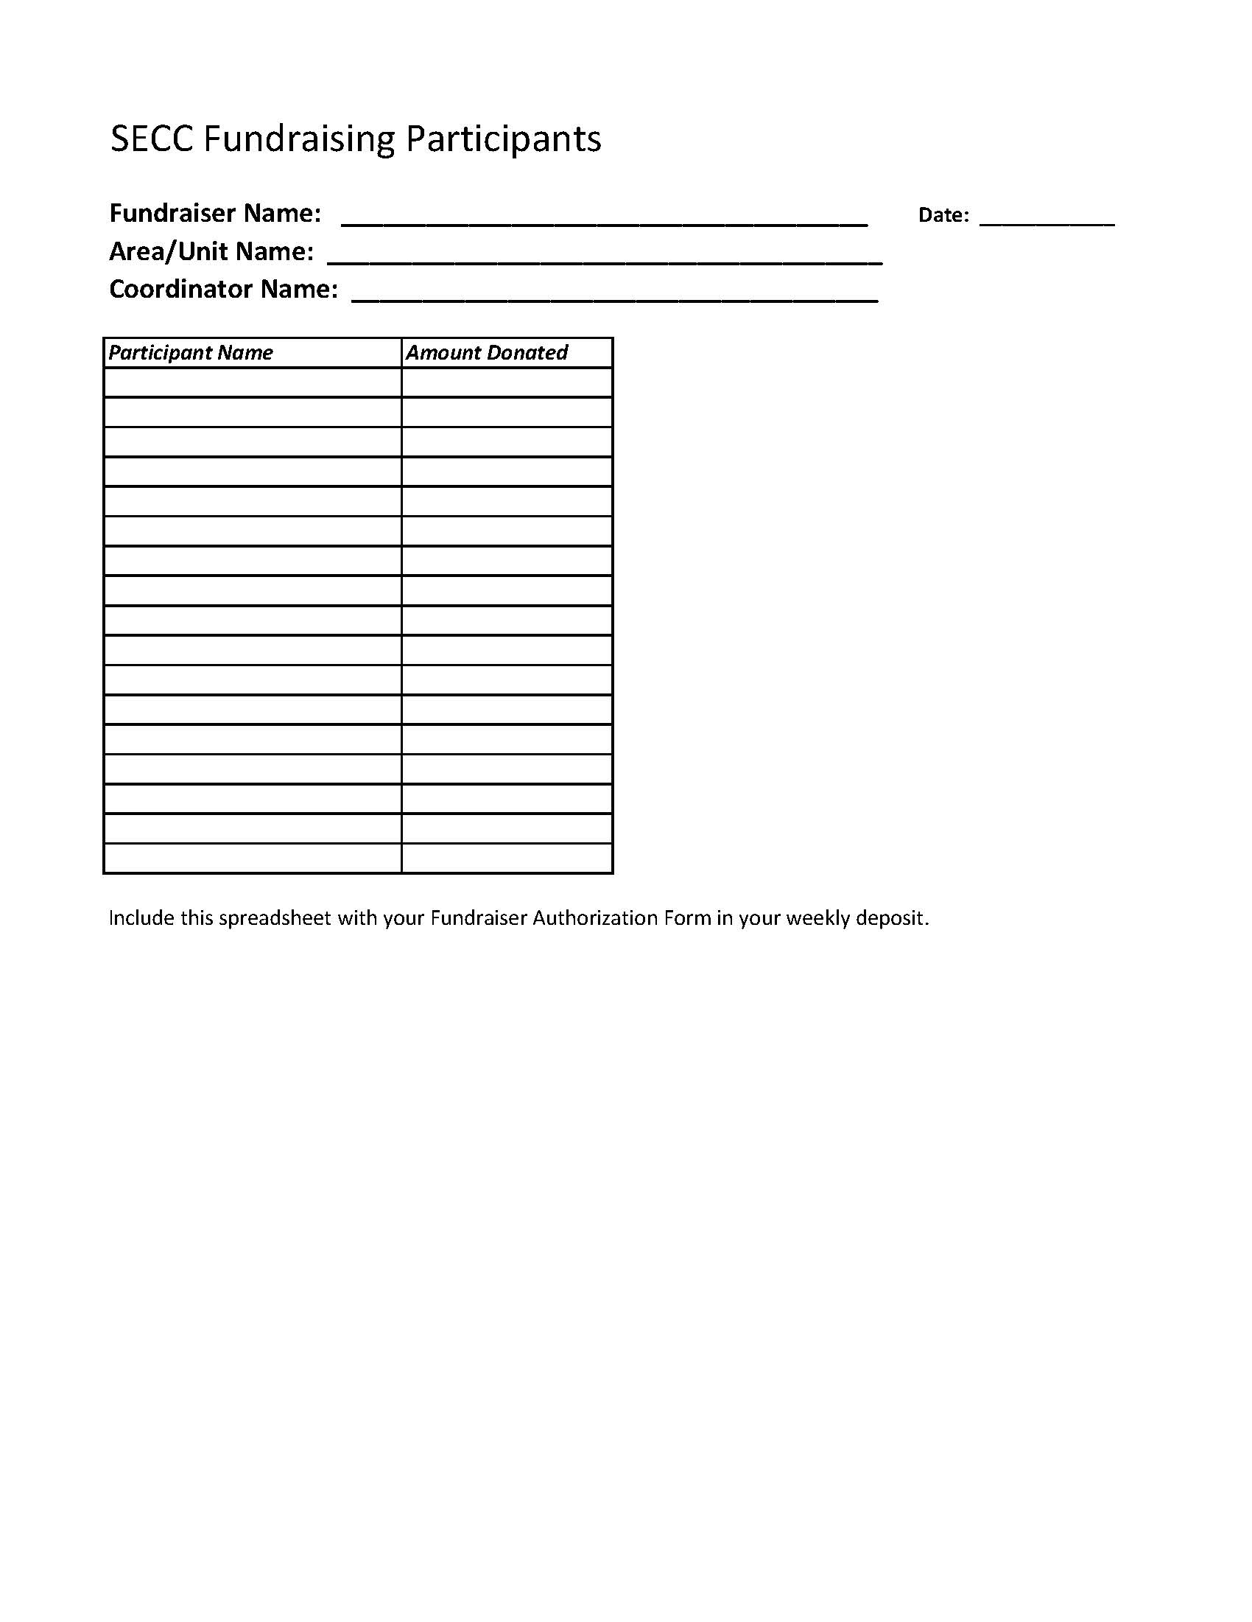

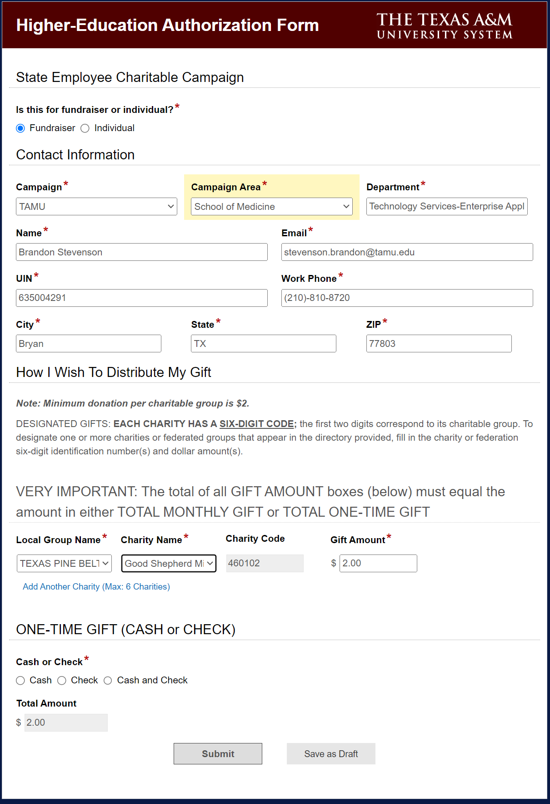
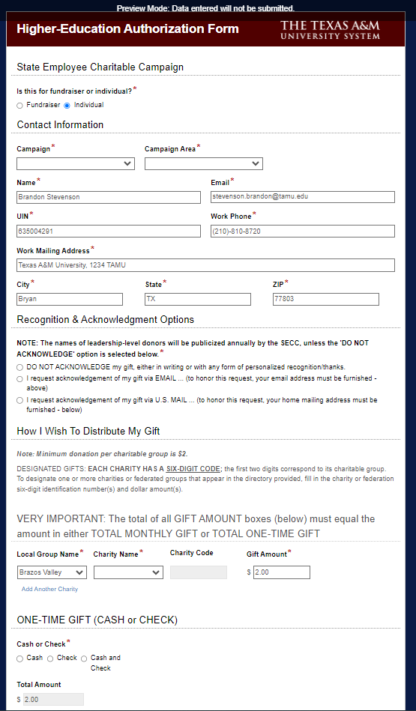
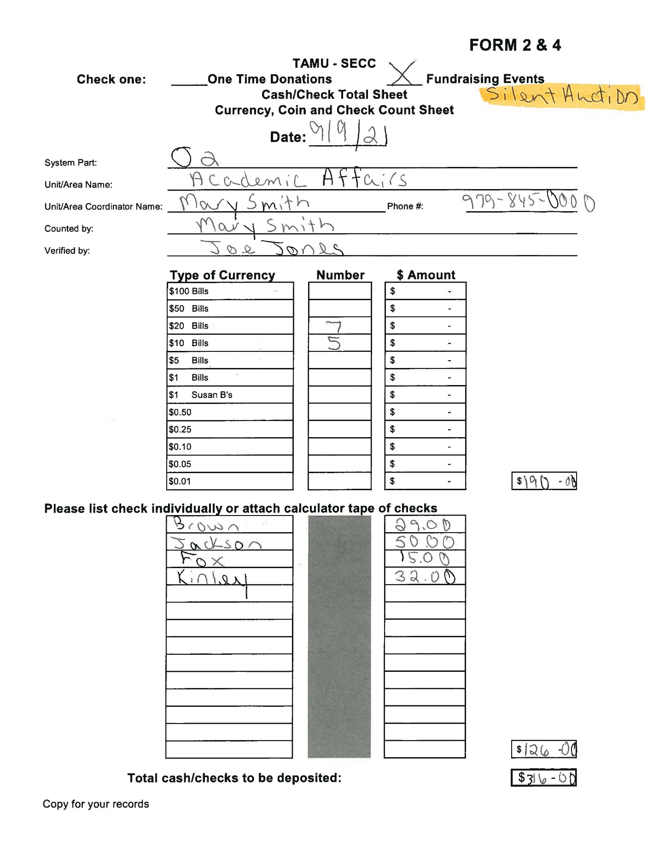
25
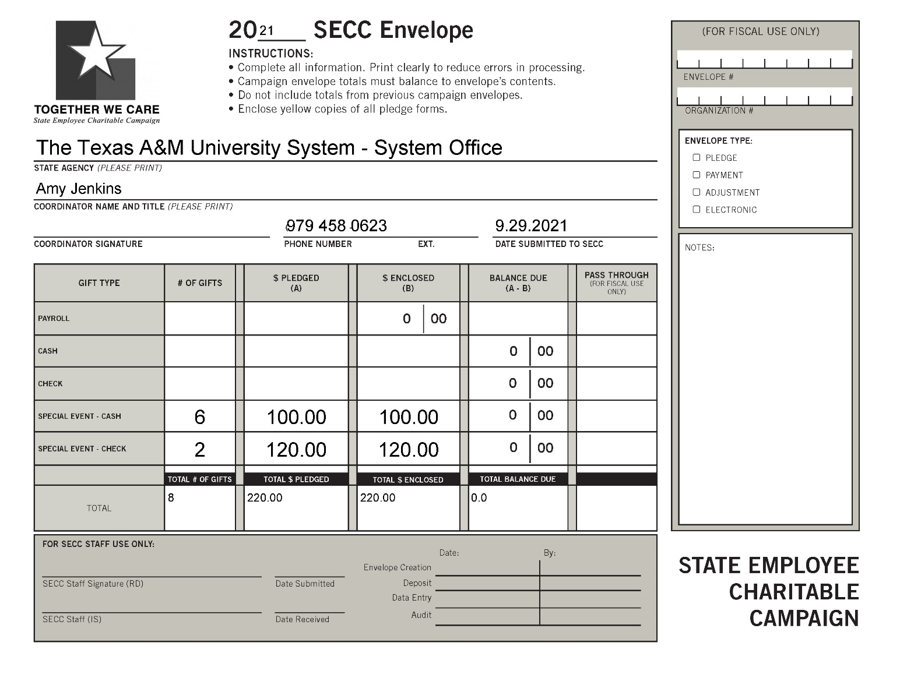

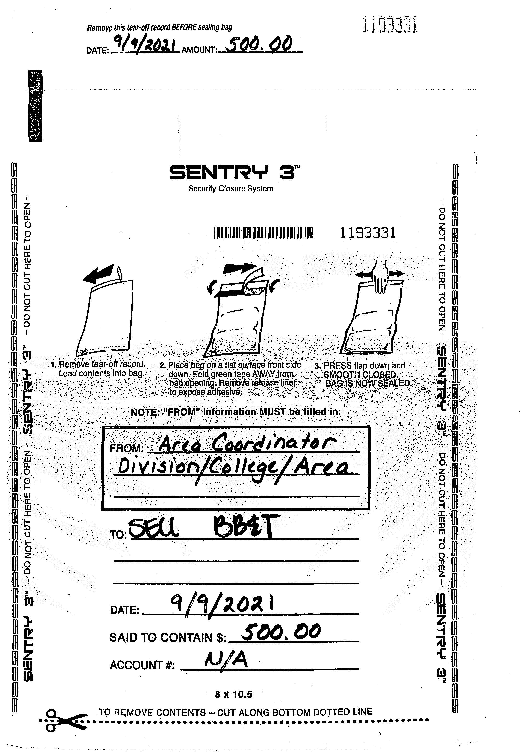
WELLS FARGO
SECC Calendar 2026
AUGUST
17 | 18 | 19 | 20 | 21  SECC tables at Maroon & White Night
24 | 25  AREA | 26  COORDS | 27  DISTRIBUTE | 28  MATERIALS!

SEPTEMBER
AUG. 31  Message from President Distributed | 1  SECC donation site LIVE | 2  Message from Campaign Chair Distributed | 3 | 4
7 | 8 | 9  9:00 am  Forms/Cash/Pledges to Area Coords. | 10  VOLUNTEER OPPORTUNITY FAIR 2-6P Bethancourt Ballroom  3:00 pm  Deposit to FMO (GSC, 3rd Floor) | 11
14 | 15  *EARLY BIRD DEADLINE* | 16  9:00 am  Forms/Cash/Pledges to Area Coords. | 17  3:00 pm  Deposit to FMO (GSC, 3rd Floor) | 18
21 | 22 | 23  9:00 am  Forms/Cash/Pledges to Area Coords. | 25  3:00 pm  Deposit to FMO (GSC, 3rd Floor) | 25

OCTOBER
SEPT 28 | 29 | 30  9:00 am  Forms/Cash/Pledges to Area Coords. | OCT 1  *Better Late Than Never BEGINS*  3:00 pm  Deposit to FMO (GSC, 3rd Floor) | 2
5 | 6 | 7  9:00 am  Forms/Cash/Pledges to Area Coords. | 8  3:00 pm  Deposit to FMO (GSC, 3rd Floor) | 9
12 | 13 | 14  9:00 am  Forms/Cash/Pledges to Area Coords. | 15  *Better Late Than Never DEADLINE*  3:00 pm  Deposit to FMO (GSC, 3rd Floor) | 16
19 | 20 | 21  9:00 am  Forms/Cash/Pledges to Area Coords. | 22  3:00 pm  Deposit to FMO (GSC, 3rd Floor) | 23
26 | 27 | 28  9:00 am  Forms/Cash/Pledges to Area Coords. | 29  3:00 pm  Deposit to FMO (GSC, 3rd Floor) | 30/31  SSO Donation CLOSES

NOVEMBER
2 | 3 | 4  9:00 am  Forms/Cash/Pledges to Area Coords. | 5  3:00 pm  Deposit to FMO (GSC, 3rd Floor) | 6
9 | 10 | 11  9:00 am  Forms/Cash/Pledges to Area Coords. | 12  3:00 pm  Deposit to FMO (GSC, 3rd Floor)  FINAL PROCESSING DEADLINE! | 13

Typically, donation and pledge processing may continue for a week or two after the campaign ends.

** January 1 – Payroll deduction pledges begin

